
Pir Meher Ali Shah
Arid Agriculture University, Rawalpindi
Office of the controller of Examinations
Final Exam / SPRING 2021 (Paper Duration 12 hours)
THEORY
Course No.: CS-577 Course Title: Computer Networks
Total Marks: 30 Date of Exam: 5-07-2021
Degree/Semester/Section: BS(IT/CS)-4th/6th (A/B)(Morning/Evening)
Q.No. | 1 | 2 | 3 | 4 | 5 | 6 | 7 | 8 | 9 | 10 | Marks  Obtained/  Total Marks
Marks  Obtained |  |  |  |  |  |  |  |  |  |  | __/30

Total Marks in Words:
Name of the teacher: Dr. Saleem Iqbal/Dr. Kashif Sattar/Dr. Mushhad Gillani/Mr. Azhar Manzoor
Who taught the course: Signature of teacher / Examiner:

To be filled by Student

Registration No.: ………………………………………….……… Name:………………………………………………………………….

Instructions: 1. Write your Name and Registration Number in the space provided above.
2. Save the file name “YY-Arid-YourNo YourName CS577 FinalThSp21.doc”.
3. Upload file at least 1-2 hr. before deadline. 12 hrs. are for both Theory & Pract.
4. After uploading view your uploaded file that either the file is correct or not?

Question #1 (20min) [6 Marks]
A bit stream X is transmitted using the standard CRC method, where, X is the 8 bit ASCII of last two digit of your arid number and divisor will be the 8 bit ASCII of last digit of your registration year (For example a student having 18-arid-279 will use ASCII of 79 as X and ASCII of 8 as divisor). [Note: remove the left most 0’s from X as well as divisor]. Write down the complete procedure to create codeword at sender side and then check at receiver side that either the data received is correct or not?
Do mention your complete arid number before attempting the question.
Answer Question #1:

Question #2 (20min) [6 Marks]
A bit stream X is being transmitted, where; X is the ASCII of last digits of your arid number (For example a student having 18-arid-279 will use ASCII of 279 as X).
- Use 100001 as flag (starting/ending delimiter) and apply bit stuffing approach at layer 2.
- Apply Polar signaling/coding scheme on the resultant data obtained from part a of this question and represent the signal.

Do mention your complete arid number before attempting the question.
Answer Question #2:

Question #3 (20min) [6 Marks]
Assume the given class C IP Address, 192.168.0.X, where; X is the last two digits of your arid number (For example a student having 18-arid-279 will use ASCII of 79 as X [Note: in case last 2 digit are 00 then you will use first 2 digits]). Apply subnetting of 3 bits and write about:
- Network and Broadcast IP of the subnet in which this IP 192.168.0.X belongs to
- First and last valid IP of the subnet in which this IP 192.168.0.X belongs to.
- Sub-net mask of this IP after subnetting.
Do mention your complete arid number before attempting the question.
Answer Question #3:

Question #4 (20min) [6 Marks]
Draw a graph for TCP congestion control for both a) TCP Tahoe b) TCP Reno based on the following information. Also show SS, AI and MD phases on the graph.
At round 1 CWND =1 MSS
Initial ssthresh =Infinity
Timeout = At round 7
3 Duplicate ACK = At round 15
3 Duplicate ACK = At round 22
Add X round after 22, where X is your last digit of Arid number.
Answer Question #4:

Question #5 (20min) [6 Marks]
Consider the following figure where you as a client sitting in Lab-1 ae requesting TCS server for tracking of your parcel. Assuming there are three routers between you and server as shown in figure. All link bandwidth and one way propagation delays are also mentioned (ignore all other delays). The delay from client to UIIT router is X, where X is your last 2 digit of Arid Number. Find the following:
- RTT
- If client send data to server using UDP. Assuming no header overheads, what is the max throughput at server?
- What is the Path’s “bandwidth delay product” in bytes?
- What is the max TCP throughput if the server buffer is 10000 Bytes?
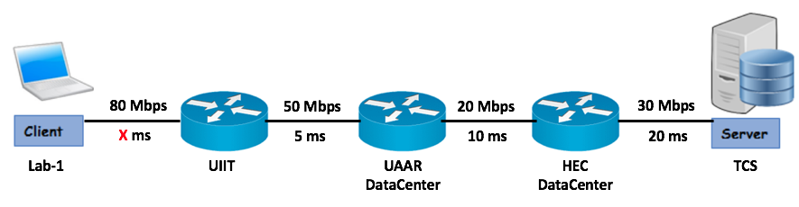
Answer Question #5:

